PROPOSAL
INNOVATION AWARD 2017

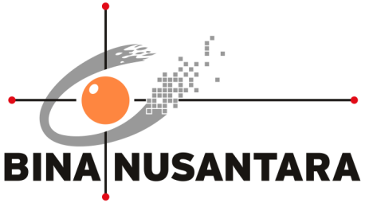

<Judul/Title>

PENGESAHAN PROPOSAL
(PROPOSAL APPROVAL)
INNOVATION AWARD 2017
BINA NUSANTARA

1. | Judul Proyek  (Project title) | : | ........................................................... ............................................................................  ........................................................... ............................................................................  ........................................................... ............................................................................
2. | Kategori  (Category) | : | - Art & Design  - Building & Environment  - Business & Management | - Humaniora  - Science & Technology  - Teaching & Learning
 |  |  | - Other: ............................................................................................
3. | Nama Tim  (Team Name) | : | ........................................................... ............................................................................
4. | Anggota Tim  (Team members) | :
No | Nama Anggota  (Member Name) | Division/Business Unit  Department/Unit  Position | Handphone  Ext  E-mail
1 | (mentor)
2 | (ketua / Team Leader)
3 | (Anggota / Team Member)
4 | (Anggota / Team Member)
5 | (Anggota / Team Member)
6 | (Anggota / Team Member)

Jakarta, <Date>, <Month>, <Year>

Mengetahui, | Team Leader
(……………………………………..) | (……………………………………..)
Direct Supervisor *

*) minimal Binusian level 13
RINGKASAN PROYEK
(PROJECT SUMMARY)
<Tidak melebihi 100 kata, ketik dengan jarak baris 1 spasi, latar belakang, rumusan masalah, tujuan dan manfaat>
<Not more than 100 words, type with 1 space, Background of the project, Problem Statement, Goal and Benefit >
………………………………………………………………………………………………………………………………………………………………………………………………………………………………………………………………………………………………………………………………………………………………………………………………………………………………………………………………………………………………………………………………………………………………………………………………………………………………………………………………………………………………………………………………………………………………………………………………………………………………………………………………………………………………………………………………………………………………………………
Keyword : ……………………………………………………………………………………………………………………

- Latar Belakang Proyek (Background of the project)
<Penjelasan kondisi saat ini dan kondisi yang diinginkan>
<Explanation of the current condition and desired condition>
………………………………………………………………………………………………………………………………………………………………………………………………………………………………………………………………………………………………………………

- Rumusan Masalah (Problem Statement)
<Gap kondisi saat ini dan kondisi yang diinginkan>
<The gap between current condition and desired condition>
………………………………………………………………………………………………………………………………………………………………………………………………………………………………………………………………………………………………………………

- Tujuan dan Manfaat (Goal and Benefit)
………………………………………………………………………………………………………………………………………………………………………………………………………………………………………………………………………………………………………………

- Rencana Penerapan Proyek (Project Implementation Plan)

No. | Aktivitas (Activity) | Bulan (Month) |  |  |  |  |  |  |  | Keluaran (Output)
 |  | Mei | Jun | Jul | Aug | Sep | Oct | Nov | Dec

- Perkiraan Efisiensi Sumber Daya (Resource Efficiency Estimation)
Sebelum (Before):
………………………………………………………………………………………………………………………………………………………
………………………………………………………………………………………………………………………………………………………Setelah (After):
………………………………………………………………………………………………………………………………………………………
………………………………………………………………………………………………………………………………………………………ROI:
………………………………………………………………………………………………………………………………………………………………………………………………………………………………………………………………………………………………………………

- Resiko Proyek (Project Risk)
………………………………………………………………………………………………………………………………………………………………………………………………………………………………………………………………………………………………………………

LAMPIRAN
(APPENDIX)

A.1 <Judul Lampiran / Titles of Appendix>
(Kuesioner, gambar / foto, dokumen tambahan yang berhubungan dengan proyek)
(Questionnaires, pictures / photos, additional documents related to the project)

