How to use Vote system for Innovation Award’s Top 15?

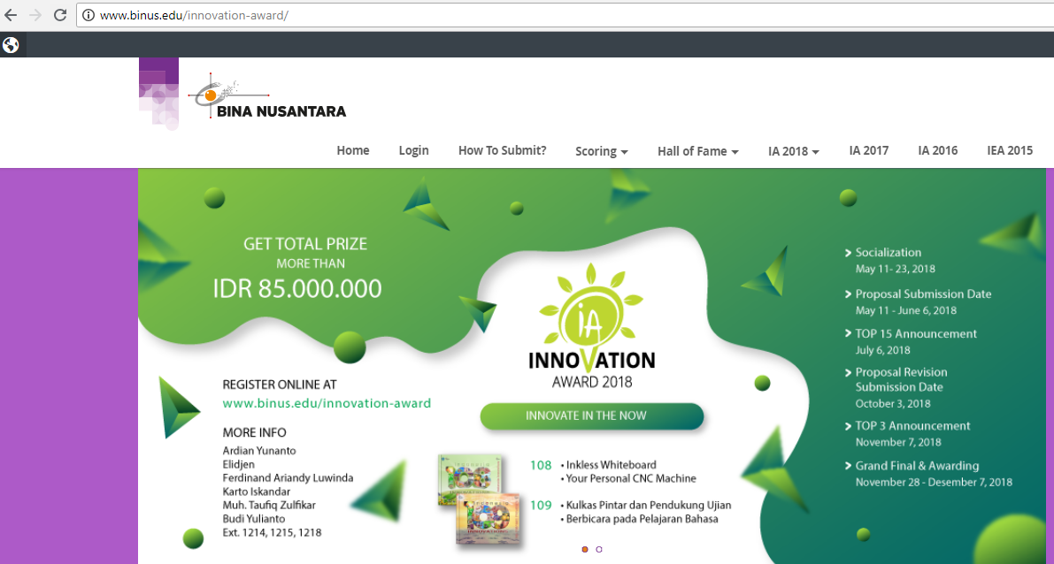
- Enter link: www.binus.edu/innovation-award

- Click “Login”
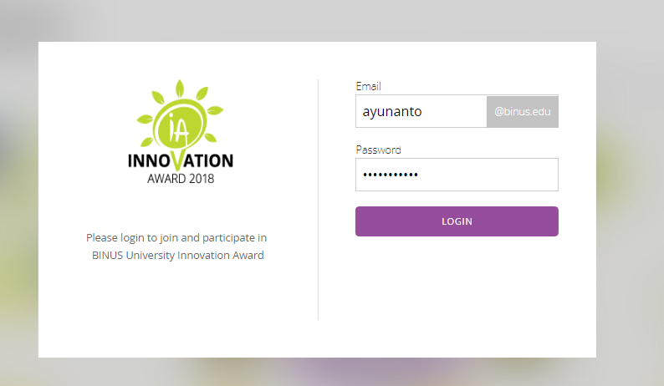
- Enter the username & password by using your Edu’s email & password
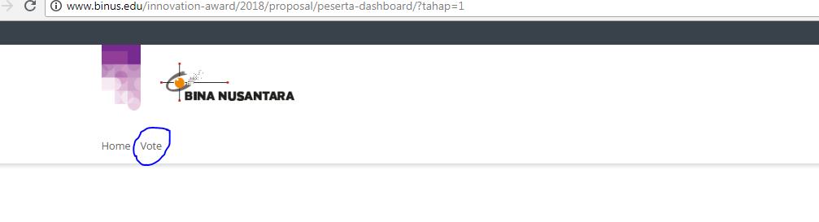
- Click “Vote” on the upper left screen

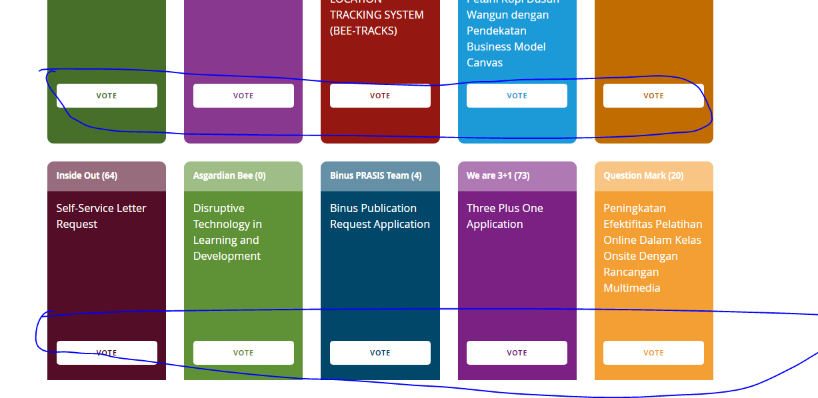
- Choice your favorite proposal (1 account can only vote 1 proposal)

